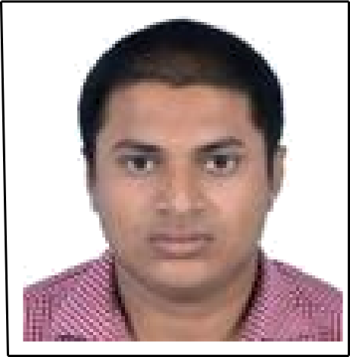
VIVEK KUMAR PANDEY
ADDRESS: C-90, Ganesh Nagar Pandav Nagar Complex , NEW DELHI- 110091
PHONE: +91-8920508828, 7205401065
E-MAIL: vivek_pandey25@yahoo.in

CAREER OBJECTIVE:

Seeking an opportunity for working as a professional in a challenging environment, to utilize my education and technical skills for the growth of the organization.

EDUCATIONAL QUALIFICATION:

Course of Study | Board | School/College | Year of Passing | %/CGPA
B.TECH (EEE) | B.P.U.T | Gandhi Institute For Education & Technology | 2015 | 7.59
12th | C.B.S.E | D.A.V Public School, Koyla nagar, Dhanbad | 2010 | 66%
10th | C.B.S.E | Rajkamal Saraswati Vidya Mandir, Dhanbad | 2008 | 72%

SOFTWARE PROFICIENCY:
- AutoCAD Electrical
- PLC Programming
- Fundamental of C
AREA OF INTEREST:
- Electrical Machine, Renewable Energy, Control Panel Design, Electrical Maintenance.
PROJECT WORK AND SEMINAR:
- Minor project on voltage control rectifier circuit.
(This circuit uses uncontrolled rectifier and IC (LM7805, LM7812) and transformer which gives output of 12 VDC & 5VDC using 230V AC.)
- Presented a seminar on the topic “Black Hole”.
- Major project on Home Automation using Android application.
(Using arduion Uno board, Bluetooth 4.0 and android app for communication.)
VOCATIONAL TRAINING & WORKSHOP:
- Attained 15 Days (17/06/2013 to 01/07/2013) training program from “JHARKHAND POWER TRAINING INSTITUTE” (PTPS, PATRATU).
- Attained State level carrier development workshop on LAB VIEW, conducted by ECE Department, Spintronic College Bhubaneshwar.
COMPLETED AUTOMATION PROFESSIONAL TRAINING AT MAX INDUSTRIAL AUTOMATION TRAINING INSTITUTE, DELHI BRANCH
- Hands on experience to program, troubleshoot and communication on PLCs i.e. Allen Bradley (Micrologix 1000), Schneider Electric (Tudio plc), LnT(LN700), Mitsubishi.
- Schneider (Altiver-11 & Altiver-31) 2wire/ 3wire/ multispeed.
- Setting up of parameter of AC drives manually and in auto mode.
- Panel designing and maintenance.
WORK EXPERINCE:
- Worked as “GET” in Treo Engineering Pvt Ltd from 8th sept. 2015 to 8th feb 2017.
JOB RESPONSIBILITY:
- PLC Programming
- Control Panel Maintenance
- Costumer Relationship
- Service report Preparation
- Service Co-ordination

- Working as “Electrical Engineer” in Hi-Tech Agro Energy Pvt Ltd. From 2nd march 2017 to 21st December.
JOB RESPONSIBILITY:
- Electrical Drawing preparation
- Control Panel Testing
- Service Co-ordination
- Service Report
- BOQ Preparation
- Switch Gears Selection
- Control Panel Costing
- Working as “Electrical Engineer” in Sheel Biotech Ltd. From 22nd December 2017 to present.
JOB RESPONSIBILITY:
1. Electrical Drawing preparation
2. Control Panel Testing
3. Service Co-ordination
4. Service Report
5. BOQ Preparation
6. Switch Gears Selection
7. Control Panel Costing

Additional Responsibility:
- Project in charge for Solar Pumping and lighting System.
- Searching for new market.
- Alignment with govt. departments for new projects.
- Alignment for Licenses and documents required.
- Co-ordination with Contractors and team for execution of project.

HOBBIES AND EXTRA-CURRICULAR ACTIVITIES:
- Participated in State level & National Level volleyball championship
- Solving critical circuit related problem
- Riding bike
- Travelling
DECLARATION:
I hereby declare that all the above statement mentioned are true and complete to the best of my knowledge.
Date: Signature
Place:
(Vivek Kumar Pandey)

